BAZIL UDDIN KHAN 24K-0559 BSCS 3H

Task 1).
Output :

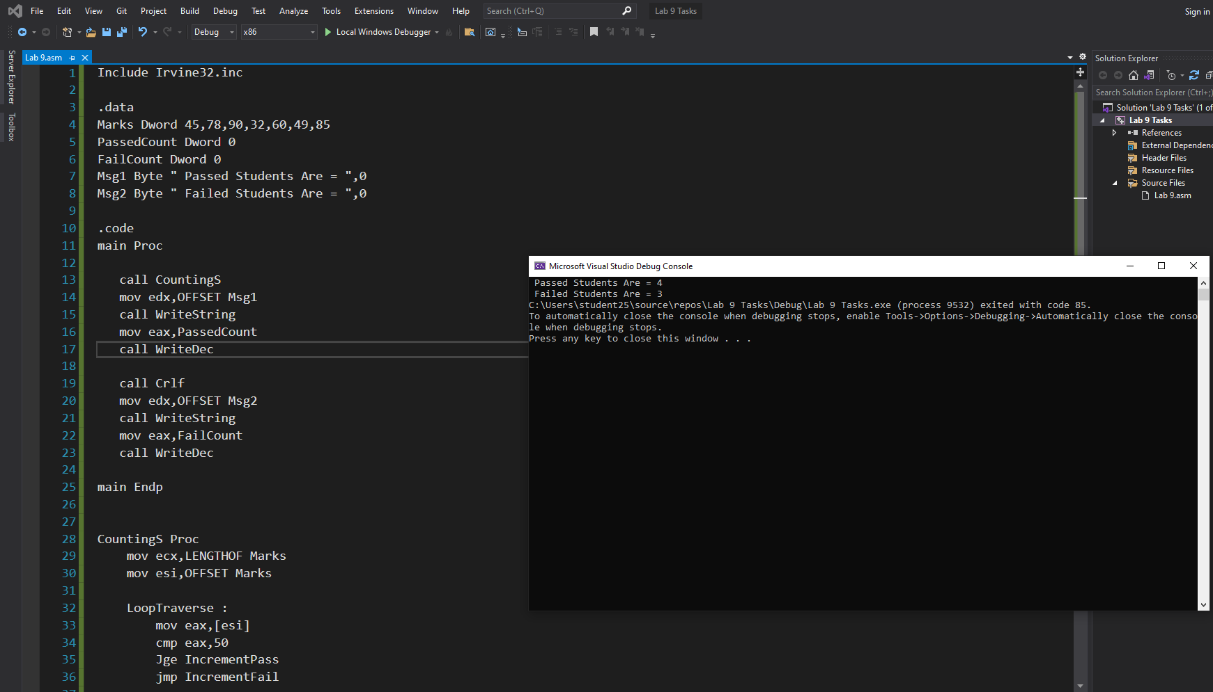
Code :
Include Irvine32.inc

.data
Marks Dword 45,78,90,32,60,49,85
PassedCount Dword 0
FailCount Dword 0
Msg1 Byte " Passed Students Are = ",0
Msg2 Byte " Failed Students Are = ",0

.code
main Proc

call CountingS
mov edx,OFFSET Msg1
call WriteString
mov eax,PassedCount
call WriteDec

call Crlf
mov edx,OFFSET Msg2
call WriteString
mov eax,FailCount
call WriteDec

main Endp

CountingS Proc
mov ecx,LENGTHOF Marks
mov esi,OFFSET Marks

LoopTraverse :
mov eax,[esi]
cmp eax,50
Jge IncrementPass
jmp IncrementFail

IncrementPass :
inc PassedCount
jmp Ltraverse

IncrementFail :
inc FailCount

Ltraverse :
add esi,4
loop LoopTraverse

ret

CountingS Endp
End Main

Task#2).
Output:
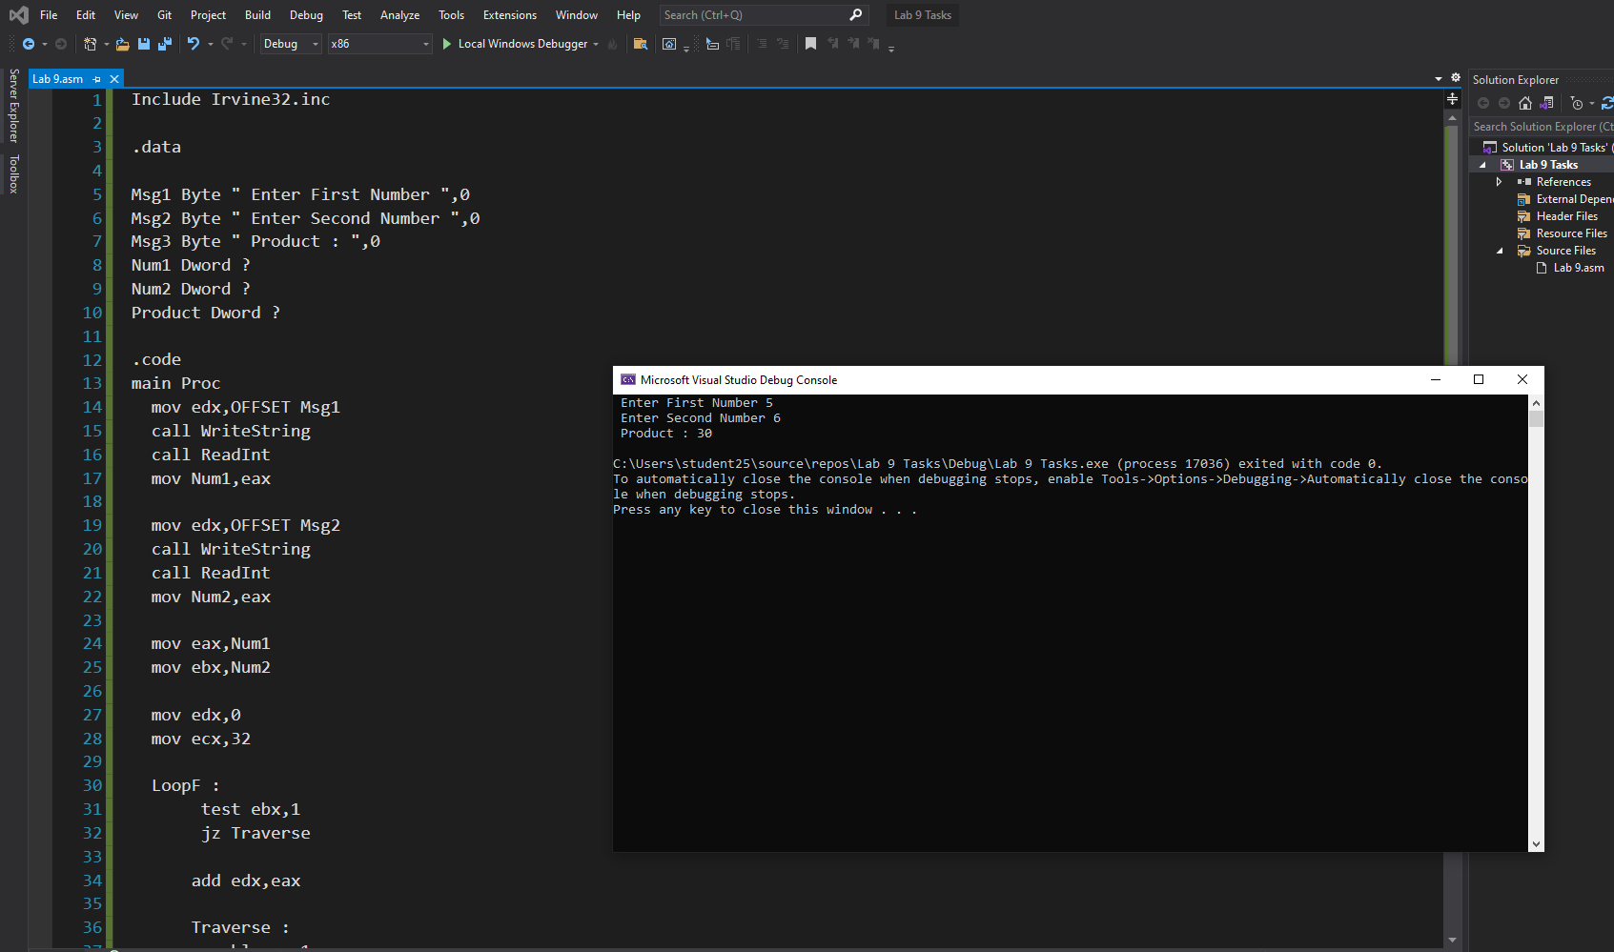
Code:
Include Irvine32.inc

.data

Msg1 Byte " Enter First Number ",0
Msg2 Byte " Enter Second Number ",0
Msg3 Byte " Product : ",0
Num1 Dword ?
Num2 Dword ?
Product Dword ?

.code
main Proc
mov edx,OFFSET Msg1
call WriteString
call ReadInt
mov Num1,eax

mov edx,OFFSET Msg2
call WriteString
call ReadInt
mov Num2,eax

mov eax,Num1
mov ebx,Num2

mov edx,0
mov ecx,32

LoopF :
test ebx,1
jz Traverse

add edx,eax

Traverse :
shl eax,1
shr ebx,1
loop LoopF

mov Product,edx

mov edx,OFFSET Msg3
call WriteString

mov eax,Product

call WriteDec
call Crlf

exit
main Endp
End Main

Task#3).
Output:
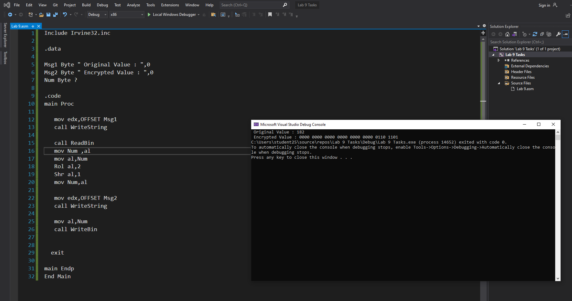

Code:
Include Irvine32.inc

.data

Msg1 Byte " Original Value : ",0
Msg2 Byte " Encrypted Value : ",0
Num Byte ?

.code
main Proc

mov edx,OFFSET Msg1
call WriteString

call ReadInt
mov Num ,al
mov al,Num
Rol al,2
Shr al,1
mov Num,al

mov edx,OFFSET Msg2
call WriteString

mov al,Num
call WriteBin

exit

main Endp
End Main

Task#4).
Output:
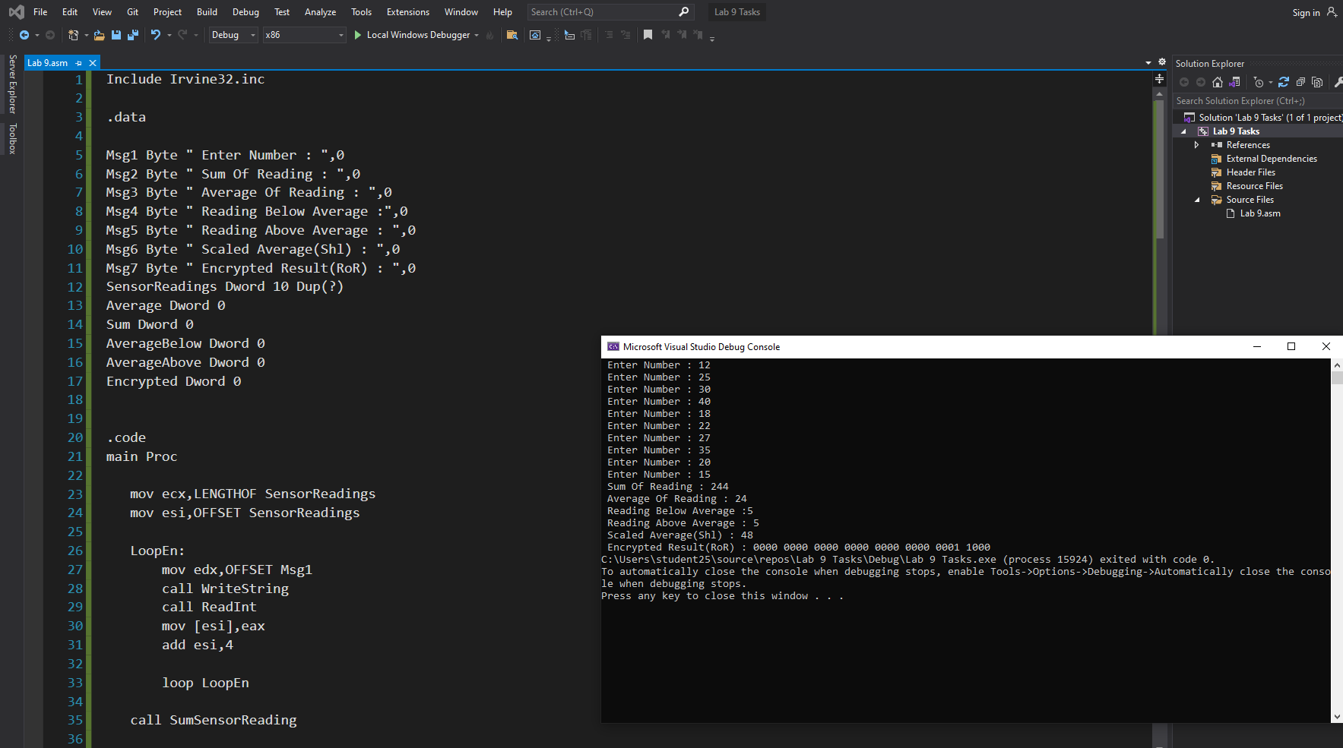
Code:
Include Irvine32.inc

.data

Msg1 Byte " Enter Number : ",0
Msg2 Byte " Sum Of Reading : ",0
Msg3 Byte " Average Of Reading : ",0
Msg4 Byte " Reading Below Average :",0
Msg5 Byte " Reading Above Average : ",0
Msg6 Byte " Scaled Average(Shl) : ",0
Msg7 Byte " Encrypted Result(RoR) : ",0
SensorReadings Dword 10 Dup(?)
Average Dword 0
Sum Dword 0
AverageBelow Dword 0
AverageAbove Dword 0
Encrypted Dword 0

.code
main Proc

mov ecx,LENGTHOF SensorReadings
mov esi,OFFSET SensorReadings

LoopEn:
mov edx,OFFSET Msg1
call WriteString
call ReadInt
mov [esi],eax
add esi,4

loop LoopEn

call SumSensorReading

mov edx,OFFSET Msg2
call WriteString

mov eax,Sum
call WriteDec
call Crlf

mov edx,OFFSET Msg3
call WriteString
mov eax,Average
call WriteDec
call Crlf

mov ecx,LENGTHOF SensorReadings
mov esi,OFFSET SensorReadings

LoopFind :
mov eax,[esi]
cmp eax,Average
jg IncrementGreater
jmp IncrementDown

IncrementGreater :
inc AverageAbove
jmp Traverse

IncrementDown :
inc AverageBelow

Traverse:
add esi,4
loop LoopFind

mov edx,OFFSET Msg4
call WriteString
mov eax,AverageBelow
call WriteDec
call Crlf

mov edx,OFFSET Msg5
call WriteString
mov eax,AverageAbove
call WriteDec
call Crlf

mov eax,Average

shl eax,1

mov edx,OFFSET Msg6
call WriteString

movzx eax,al
call WriteDec
call Crlf

RoR eax,1

mov Encrypted,eax
mov edx,OFFSET Msg7
call WriteString

call WriteBin

exit

main Endp

SumSensorReading Proc
mov esi,OFFSET SensorReadings
mov ecx,LENGTHOF SensorReadings

LoopSum:
mov eax,[esi]
add Sum,eax
add esi,4

loop LoopSum

mov eax,Sum
mov ebx,10
xor edx,edx

div ebx
mov Average,eax

ret

SumSensorReading Endp
End Main

